GRADE 7 ACCELERATED · UNIT 1  Practice Test  Equations and Inequalities | Name_________________________  Date__________________________  Period________________________  Score __________ / 21

DIRECTIONS. Show your work for every question. Write repeating decimals with a bar over the digits that repeat. Fractions do not have to be in simplest form. Where a question gives units, include them in your answer.
READ THIS FIRST. This practice test is the test — same twelve questions, same order, same point values, only the numbers are different. Nothing on the test will look like anything you have not seen here.
 | What it covers | Questions | Points
A | Equivalent forms of rational numbers | 1, 2 | 7
B | Writing and solving an equation from a situation | 3, 7 | 4
C | Solving two-step equations | 4, 5, 6 | 3
D | Deciding whether a value solves an inequality | 8 | 1
E | Solving and graphing inequalities | 9, 10, 11 | 3
F | An inequality in a real-world situation | 12 | 3

1. Complete the table by writing the equivalent value in each empty cell. | 3 points

 | Fraction | Decimal | Percent
a. | 5/9
b. |  | 0.65
c. |  |  | 48%

2. Devon opens a bag of fruit chews with five flavors. The table shows what part of the bag is each flavor. | 4 points

Flavor | Amount
Cherry | 25%
Grape | 7/45
Lemon | 0.15
Orange | 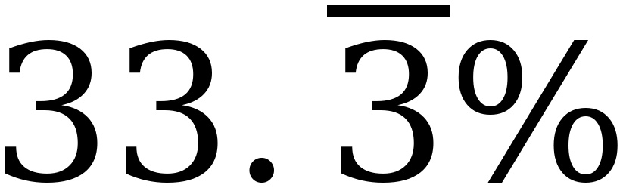
Berry | 

a. What percentage of the bag is Lemon? 1 point |  |  | b. Rewrite the amount that is Grape as a decimal. 1 point
Percentage |  |  | Decimal

c. What fraction of the bag is Berry? 1 point |  |  | d. Rewrite the amount that is Cherry as a decimal. 1 point
Fraction |  |  | Decimal

3. Rashad is saving for a summer camp. He is paid the same amount every week. Each week he uses $415 of his pay for expenses and saves everything that is left. After 9 weeks he has saved $423. | 2 points

a. Write an equation that can be used to determine the amount, x, in dollars that Rashad is paid each week. | 1 point

Equation

b. Solve the equation. | 1 point

Solution

Solve each equation. Show your work.
4. −6(w + 5) = 96  1 point |  |  | 5. n ÷ (−4) + 2.6 = −5.9  1 point |  |  | 6. 2 ⅚ = 7 ¼ − k  1 point
Solution |  |  | Solution |  |  | Solution

7. A server at the Lakeside Diner earns $9.40 per hour plus $64.60 in tips. | 2 points

a. Write an equation that can be used to determine the number of hours, h, the server worked to earn $135.10. | 1 point

Equation

b. Solve the equation. | 1 point

Solution

8. Circle every value below that is a solution to −2x + 5 ≥ 17 . | 1 point

−11 | −6⅓ | −6 | −5 | 0 | 4

Solve each inequality. Show your work, then graph the solution set on the number line.
9. −9.7 > −2x − 1.3 | 1 point

Solution

10. ⅔ (18 − 15x) > 64 | 1 point

Solution

11. −6(4x + 7) ≥ 150 | 1 point

Solution

12. The chess club is renting a van for a tournament. The rental company charges a flat fee of $180 plus $16 for each student who rides. The club has raised $700 and wants to take as many students as possible. | 3 points

a. Write an inequality that can be used to determine the number of students, s, who can ride the van. | 1 point

Inequality

b. Solve the inequality. | 1 point

Solution

c. How many students can ride? Justify your answer mathematically. | 1 point

